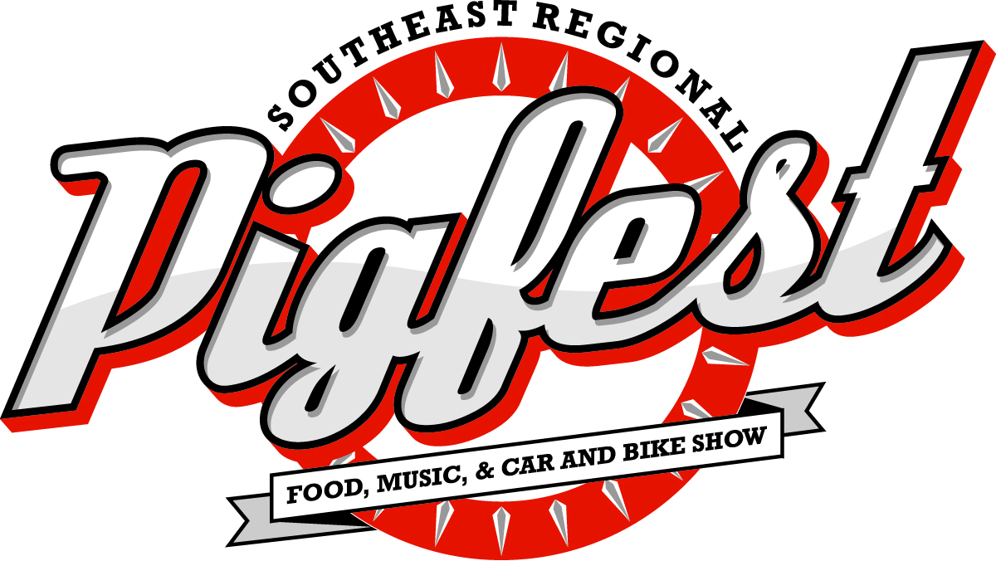

**June 6, 2015**

**10 AM – 5:30 PM**

**North Florida Fairgrounds**

**441 N Paul Russell Rd, Tallahassee, FL  
www.cacaainc.org (850) 222-2043 x101**



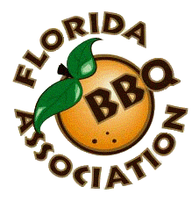

**FOOD VENDOR REGISTRATION**

**RULES & REGULATIONS**

1. **Booth Fees: (Electricity available by request):**

**$150 Before December 31**

**$175 January 1 – until reach capacity**

1. **Spaces are 10 feet x 20 feet.** (You must inform us if you need additional space). **$50 fee for each additional 5 feet of space.** Must maintain booth space until 5:30 pm Saturday. You choose your site spot – using online site map, registration and payment will be the easiest way to choose and reserve your site’. It will belong to you on the next business day upon receipt of payment. Tell a friend your site number and have them register next to you. ‘ It’s that easy. No guesswork on where you’ll be assigned because you choose your site.
2. Food vendors may begin assembling areas between 10:00am-6:30pm Friday and 7:00am Saturday. **There are no exceptions to the set up dates.** Areas must be set up and vehicles removed from the square by 9:00am Sat. Areas must be set up and **all service/supply vehicles removed from the grounds. Must maintain space until close of festival. All vendor/concession stations must be set up and ready for the public by 9:00 am, Saturday, June 5, 2015.** Sales tax will be collected. Health Inspection will be conducted on Friday afternoon.

## Electrical power is provided only for those who request it. Extension cords will not be provided.

1. Canopies are welcomed and encouraged, but **MUST NOT** exceed booth space. Any shelters, tables or display racks provided by the vendor must be removed by the vendor no later than 6:30pm Saturday. **Vending area must be clean and clear of trash and debris**.

# NO BEVERAGE MAY BE SOLD BY COOKERS/VENDERS.THERE ARE ABSOLUTELY *NO EXCEPTIONS*.

1. **Only cancellations resulting from cancellation of the event due to extreme weather, or some other reason caused by event planner will be eligible for reimbursement of prepaid registration fees when the request is made in writing by the day of the event.**
2. **Any vendor who has not paid their fees prior to the event will not be allowed to set up. NO EXCEPTIONS!**
3. Any shelters, tables or display racks provided by the participant must be removed no later than 6:30pm Saturday. Water and electrical hookups available upon request at no charge (no sewer). All vendors/contestants must adhere to all health (864/833- 0000), electrical, fire and other codes applicable to this event (must provide fire extinguisher).
4. The steering committee reserves the right to deny any application at any time.
5. **Food vendors must present a certificate of insurance showing Capital Area Community Action Agency as an Additional Named Insured with your application. If vendor does not carry insurance, you may be added to the agency’s policy for a $50 fee.**

**Items NOT PERMITTED by participants:**

* Alcoholic beverages of any kind.
* Anything that can be considered a weapon of any kind
* Fireworks, stink bombs, etc.

**All items MUST BE APPROVED by the Southeast Regional PIGFEST Event Committee prior to setting up booth.**

**Southeast Regional Pigfest – June 6, 2015**

***FOOD VENDOR Application Form***

*Date Received*

*Approved Unapproved*

|  |
| --- |
| VENDOR NAME: (Please Print) |
| ADDRESS: |
| CITY: STATE: ZIP: |
| TELEPHONE: |
| EMAIL: |
| **Food Description:**  **All food items must be listed. Vendors will only be allowed to sell the items listed. Attempting to sell or give away any item not listed may result in your being asked to leave the festival. This will be strictly enforced and no exceptions will be granted. NO BEVERAGE SALES ALLOWED.** |
| WILL YOU BE USING A TENT? YES NO SPECIAL NEEDS: |
| WILL YOU REQUIRE AN ELECTRICAL CONNECTION? YES NO |
| Mail this application and ALL fees payable by check, money order, or credit card to:  **Capital Area Community Action Agency Southeast Regional PIGFEST**  **309 Office Plaza Drive Tallahassee, FL 32301**  .  **TOTAL AMOUNT SUBMITTED $_**  **Participant's Agreement**  The undersigned agrees that he/she will be responsible for any loss or damage to his/her work during Southeast Regional PIGFEST and enclosed payment. I understand that failure to abide by the terms of this event may result in the termination of my contract and my participation in future events with Capital Area Community Action Agency.  Registration and rental fees must accompany this application. |
| PARTICIPANT’S SIGNATURE |

**CONDITIONS**

The Southeast Regional Pig Fest Barbecue Cook-off Committee reserves the right to reject any application. If your application is not accepted, your money will be refunded. However, no refunds of the application fee will be made once you have been accepted into the contest. Any photographs or videos taken of your team on-site become the property of Capital Area Community Action Agency and may be used for promotional purposes.

By signing the application, contestants agree to indemnify and hold Capital Area Community Action Agency, the Southeast Regional Pig Fest Committee, the city of Tallahassee, their employees, agents and volunteers, harmless from any and all claims made against same; including without limitation, all costs, liabilities, judgments, expenses, damages or reasonable attorneys’ fees, arising out of, or in connection with; (1) any structure erected by Vendor/Contestant; (2) any apparatus, equipment or personal property used by Vendor/Contestant; (3) any act or omission to act of Vendor/Contestant, its agents, invitees, participants, representatives, employees, servants, and assigns; and (4) any claims made on account or resulting from contestants participating in the contest. Any legal action concerning this contract will be conducted in the County of Tallahassee, Florida.