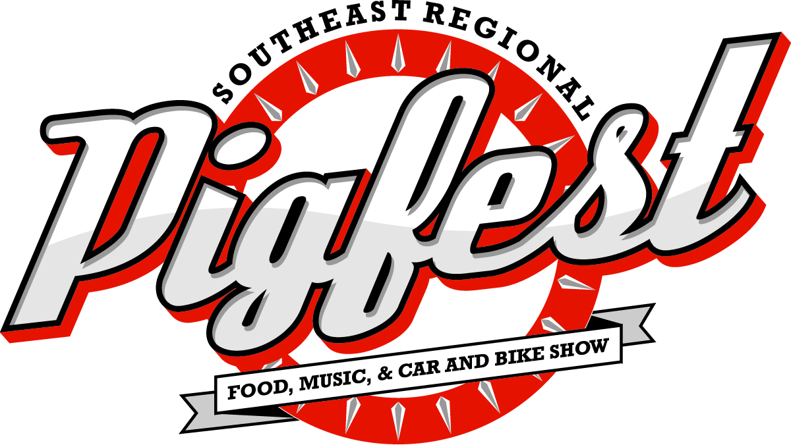

**June 6, 2015**

**10 AM – 5:30 PM**

**North Florida Fairgrounds**

**441 N Paul Russell Rd, Tallahassee, FL  
www.cacaainc.org (850) 222-2043 x101**

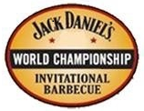

*Judge's Application*



First Middle Last



Street City State Zip

**Telephone: ______________________________________**

**E-mail: ______________________________________________**

*All judges must be certified by the FL BBQ Association*

Approved judges list will be posted no later than April 30, 2015

Southeast Regional Pigfest will be held on Saturday, June 6, 2015 North Florida Fairgrounds, 441 Paul Russell Road, Tallahassee, FL 32301

For questions, please contact Diane Haggerty (850) 222-2043 x101

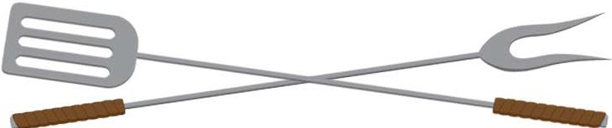

Schedule for PIGFEST Judges

**Saturday, June 6, 2015 9:00am -9:30 am: Judges Check-in**

**9:30 am: Judges Meeting**